1. **Read last Quarterly to re-familiarize**
2. **Generate a directory in Noodle to store files for this biannual**
   1. In directory \\Noodle\fot\engineering\ccdm\Current_CCDM_Files\Quarterly Report\ create a new directory with the format of “NM_YYMMM_YYMMM” where NM is the number of biannual, YYMMM is the year and month of the biannual range.
   2. Inside newly created directory, create a directory called “Files”
   3. Inside newly created “Files” directory, create a directory called “SSR”. These will store files that are read by the “CCDM Biannual.py” script.
3. **Generate BEAT reports for period**
   1. Launch the BEAT tool
      1. Using “MobaXterm” launch the BEAT tool
         1. Using MobaXterm ssh into snowman (@snowman.greta.occ.harvard.edu)
      2. cd into directory “/home/production/BEAT/bin”
      3. launch BEAT tool as follows (./run_beat &)
   2. Generate BEAT reports for period
      1. Click “database”
      2. Change date range to match range of the biannual
      3. Change output directory to something different (example “beat-out-YYYYa/b)
      4. Click “Run”
      5. Select “All”
      6. **NOTE**, will take around 20min to run, app looks dead while its running.
   3. Copy generated files from set output directory to directory “SSR” created in noodle in previous step.

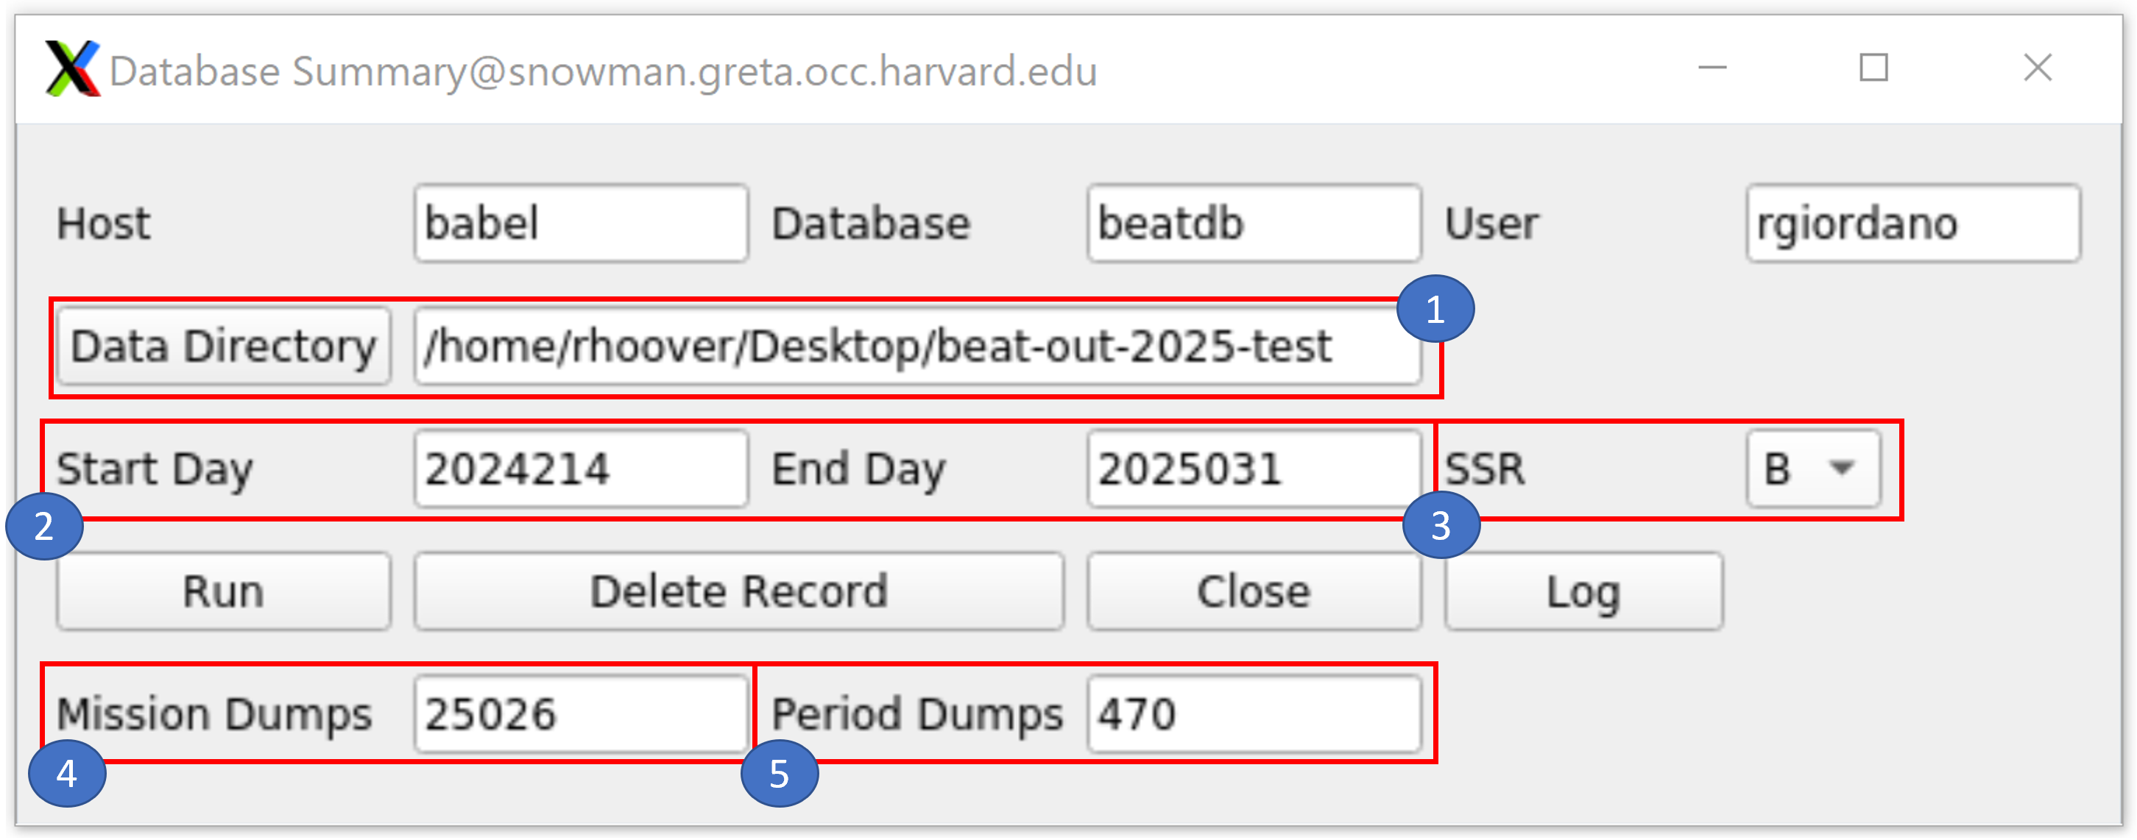

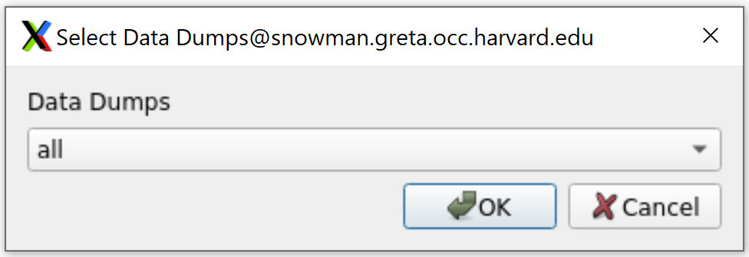

1. **Generate all SKA data plots for biannual period (via chimchim)**
   1. SSH into chimchim via a terminal (or vscode or whatever)
      1. **“ssh** [**user@131.142.113.13**](mailto:user@131.142.113.13)**”**, input password when prompted
   2. Active the ska3flight virtual environment with the following command
      1. **ska3flight**
   3. cd into the following directory with the following command
      1. **“cd /home/rhoover/python/Code/ccdm/Biannual/”**
   4. Run the CCDM Biannual Report python script with the following command
      1. **python “CCDM Biannual.py"**
   5. Follow the script instructions via the terminal window
   6. Script takes a while to run (~50min).
   7. Script will generate a new directory (if not already done) in **\\noodle\FOT\engineering\ccdm\Current_CCDM_Files\Quarterly Report**
2. **Compile auto-generated items into report.**
   1. The following items will be auto-gen’ed by the “CCDM Biannaul.py” script
      1. All png plots (65x plots for each MSID of concern)
      2. SSR html plots (8x if SSR-B was prime and 9x if SSR-A was prime)
         1. SBE_vs_DBE_by_Date.html
         2. SBE_vs_DBE_by_Submodule.html
         3. Quarterly_SSR_A_by_DoY.html
         4. Quarterly_SSR_A_by_SubMod.html
         5. Quarterly_SSR_A_Timestrip.html
         6. Quarterly_SSR_B_by_DoY.html
         7. Quarterly_SSR_B_by_SubMod.html
         8. Quarterly_SSR_B_Timestrip.html
         9. (If SSR-A was prime) Avg_SBE_Submod104.html
      3. CSV files containing raw data (14x)
      4. Transmitter vs Baseplate Temp Plot (YYYYb_TX_BPT.html)
3. **Clock Rate Data into report**
   1. From noodle directory \\noodle\fot\engineering\ccdm\Clock_Timing\Clock Rate Trending_files open file “Clock Rate Trending.xlsx”
   2. In “biannual” section, select the applicate data for your biannual period range.
   3. Ensure “Mission” tab plot has data selected up to or beyond the biannual reporting period.